
Company
Logotype

Cone Beam Computed Tomography- Report



Porur Dental X-rays & CBCT

Patient Name : Mrs. Malliga | Date of Report : 19.05.2024
Age/ Gender : 64 years/ Female | Region of Interest : CBCT Full Skull
Referring doctor: Dr. M. Anusha | Indication : Implant assessment
Clinical Notes: Nil
PATIENT INFORMATION

CBCT- Full Skull provided
CBCT – IMAGE DETAILS

RADIOGRAPHIC INTERPRETATION

- Completely missing crown and root structure in relation to maxillary arch is evident.
- Root stumps in relation to 33, 34, 44 evident.
- The alveolar ridge in relation to the maxillary and mandibular alveolar ridge is present with normal trabecular pattern.
- However, the alveolar ridge in relation to maxillary and mandibular arch is present with resorptive changes leading to reduced bone density, reduced bone width and bone height- Knife edge shaped maxillary and mandibular anterior portion of alveolar ridge is evident.
Note: presence of an accessory nerve branch in relation to 33, 34 region running from lingual aspect is evident.

IMPLANT ASSESSMENT

 | 11 region | 12 region | 13 region | 14 region | 21 region | 22 region | 23 region | 24 region
Sub-Crestal | 3.3 | 1.1 | 2.2 | 1.5 | 1.6 | 1.3 | 2.8 | 3.7
Mid- Crestal | 4.3 | 2 | 1.8 | 2.2 | 2.4 | 1.6 | 3.3 | 4.6
Distance between the alveolar ridge and Floor of the Nasal cavity (in mm) | 10.7 | 16.2 | 13.3 | 11.7 | 14.1 | 13.7 | 10.5 | 10.1

 | 15 region | 16 region | 17 region | 25 region | 26 region | 27 region
Sub-Crestal (in mm) | 1.5 | 2.1 | 2.9 | 5.4 | 4.4 | 7.1
Mid- Crestal (in mm) | 2.5 | 3 | 3.8 | - | - | 8.3
Distance between the alveolar ridge and floor of the maxillary sinus (in mm) | 8.2 | 4.8 | 4 | 4.4 | 5.8 | 5.5

 | 31 region | 32 region | 33 region | 34 region
Sub-Crestal (in mm) | 3.1 | 3.6 | 7.1 | 7.5
Mid- Crestal (in mm) | 4.2 | 5.2 | 8.2 | 7.8
Distance between alveolar ridge and the inferior border of mandible (in mm) | 24.9 | 23.5 | 20.3 | 20.2

 | 41 region | 42 region | 43 region | 44 region
Sub-Crestal (in mm) | 3.1 | 4.1 | 4.9 | 4.7
Mid- Crestal (in mm) | 4.1 | 5.2 | 5.8 | 5.6
Distance between alveolar ridge and the inferior border of mandible (in mm) | 26.1 | 26.5 | 24.4 | 27
 | 45 region | 46 region | 47 region
Sub-Crestal (in mm) | 5.5 | 3.8 | 3.8
Mid- Crestal (in mm) | 5.8 | 4.1 | 5.3
Distance between alveolar ridge and the inferior alveolar nerve canal (in mm) | 12.2 | 13.9 | 12.9
Distance between alveolar ridge and the inferior border of mandible (in mm) | 28.5 | 28.1 | 22.7

 | 35 region | 36 region | 37 region
Sub-Crestal (in mm) | 4.2 | 4.3 | 4.6
Mid- Crestal (in mm) | 5.8 | 5.4 | 5.6
Distance between alveolar ridge and the inferior alveolar nerve canal (in mm) | 9.3 | 10.4 | 11.2
Distance between alveolar ridge and the inferior border of mandible (in mm) | 23.8 | 23.3 | 22.2

RADIOGRAPHIC IMPRESSION

- Partially edentulous maxillary and mandibular arch.
- Root stumps in relation to 33, 34, 44.

Kindly correlate with clinical findings


IMAGES FOR REFERENCE

RECONSTRUCTED PANORAMIC VIEW
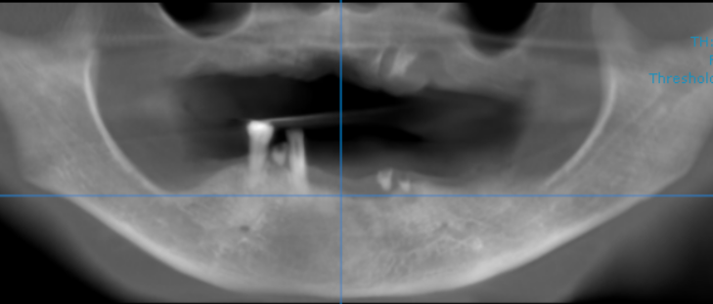

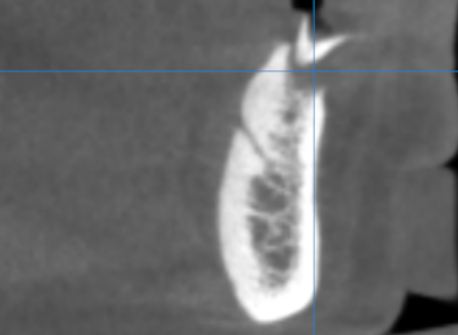

Note: presence of an accessory nerve branch in relation to 33, 34 region running from lingual aspect is evident.

3-DIMENSIONAL VIEW

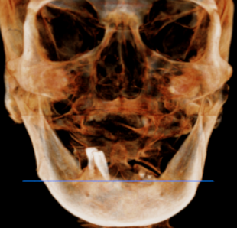

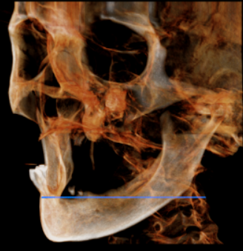
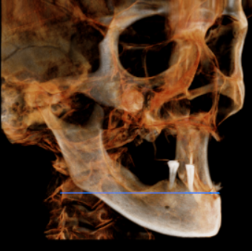

CROSS SECTIONAL VIEW

11 region | 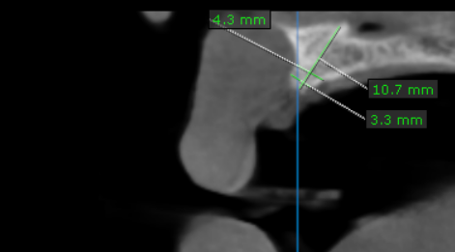
12 region | 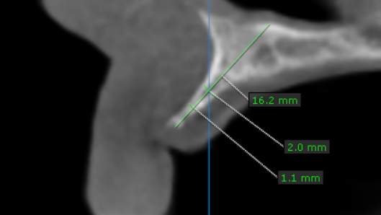
13 region | 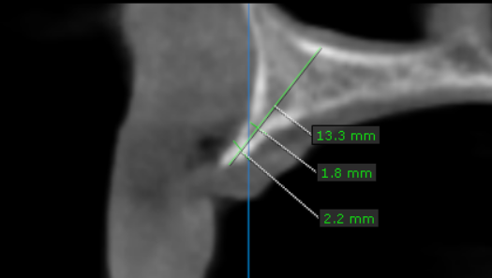
14 region | 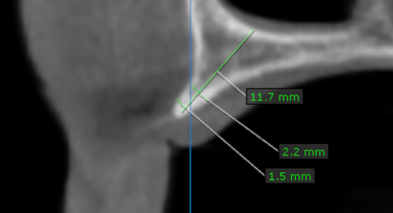
15 region | 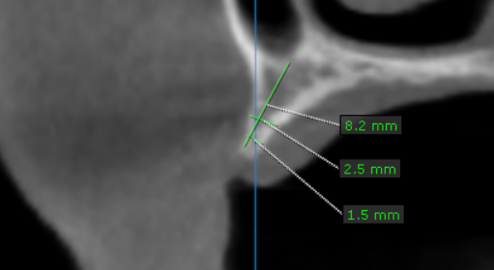
16 region | 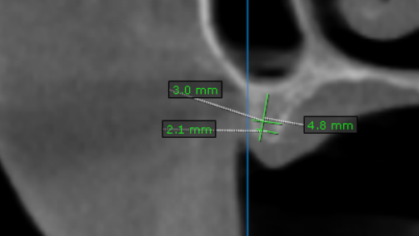
17 region | 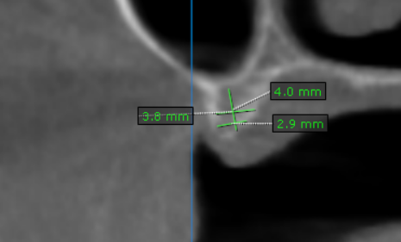
21 region | 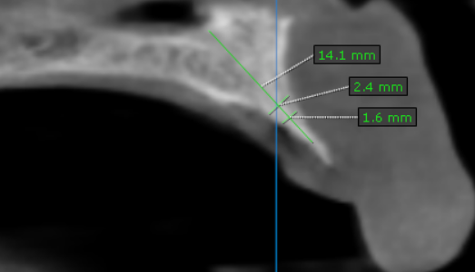
22 region | 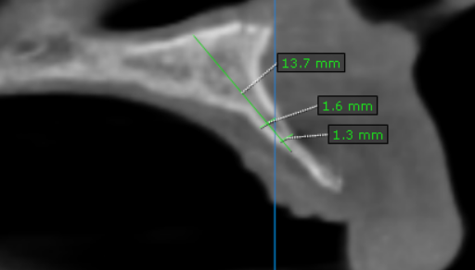
23 region | 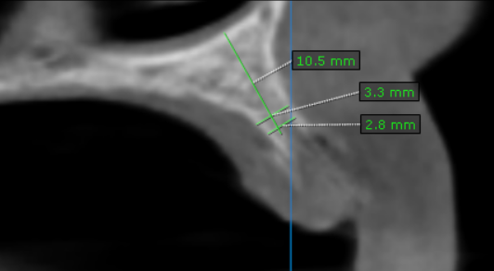
24 region | 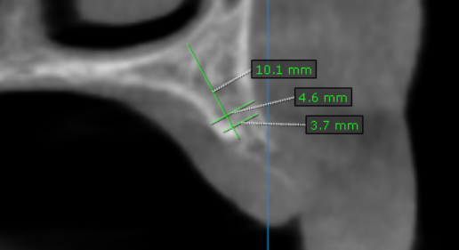
25 region | 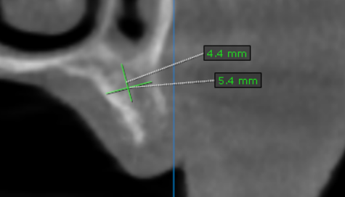
26 region | 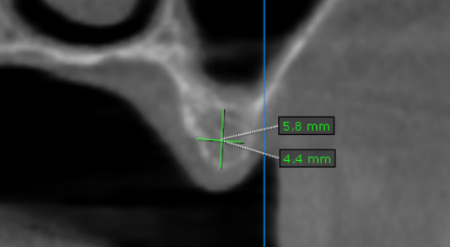
27 region | 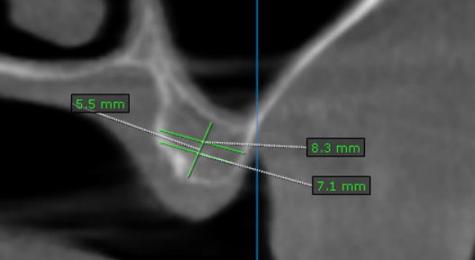
31 region | 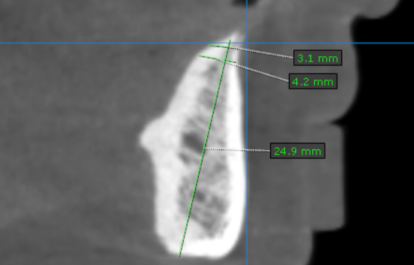
32 region | 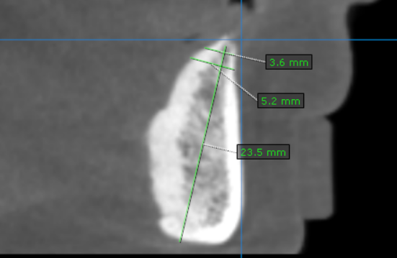
33 region | 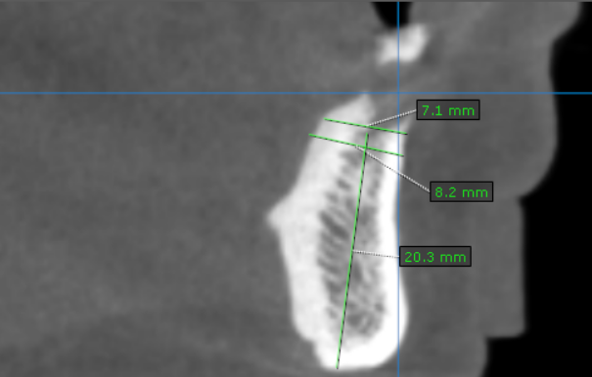
34 region | 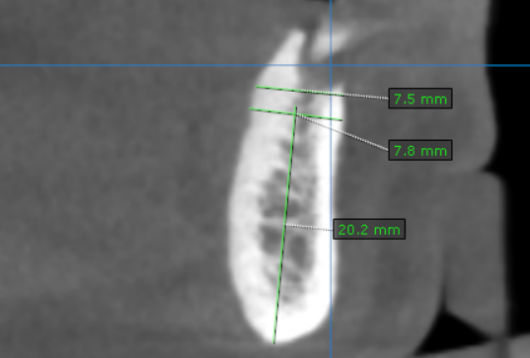
35 region | 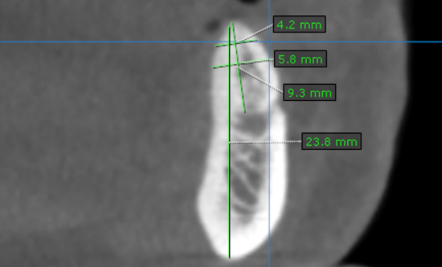
36 region | 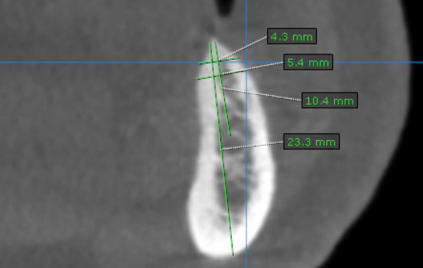
37 region | 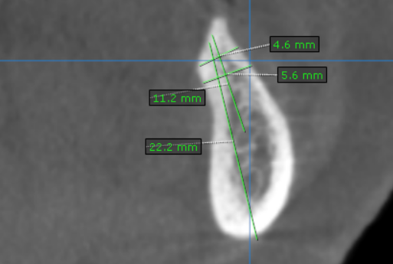
41 region | 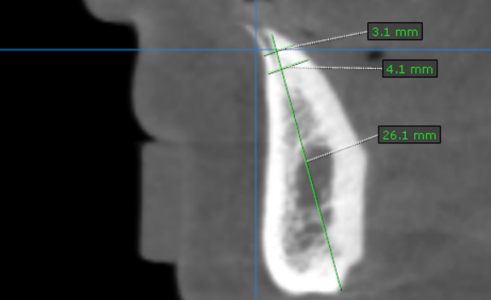
42 region | 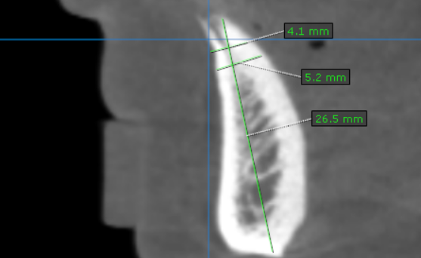
43 region | 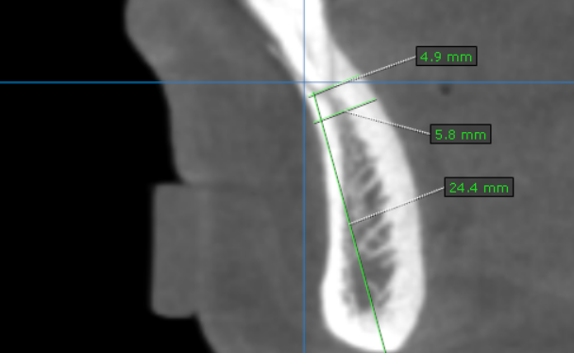
44 region | 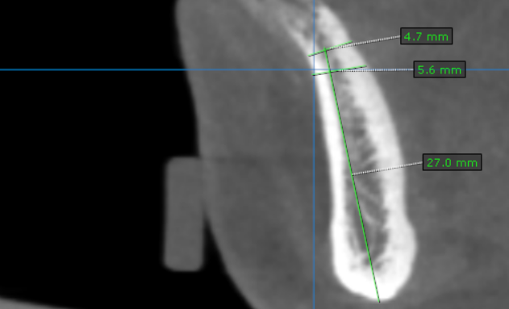
45 region | 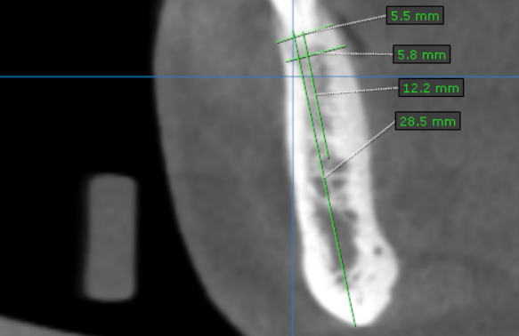
46 region | 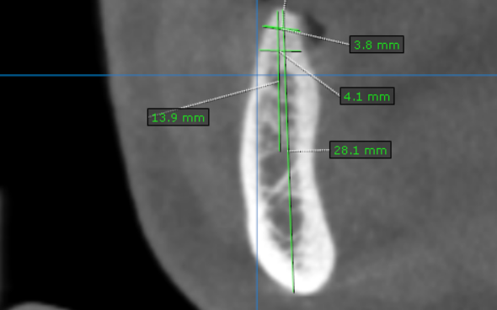
47 region | 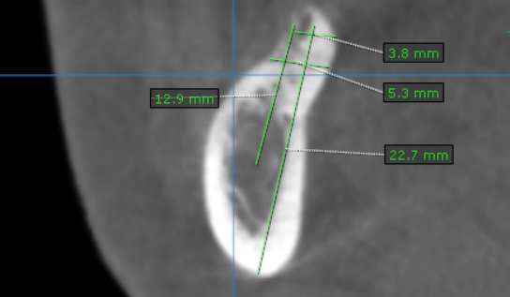

**** End of report ****

